TASK ON AUTO SCALING

*Create one vpc in N.virginia region.*

*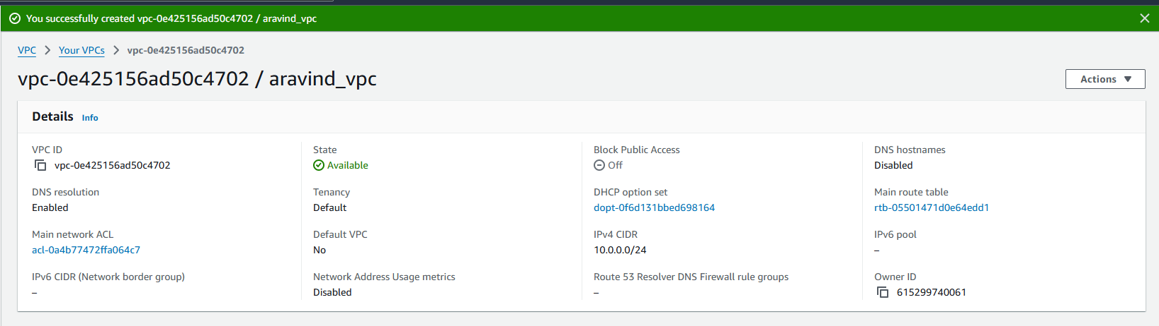*

*Create two subnets.One Public subnet and one private subnet.*

*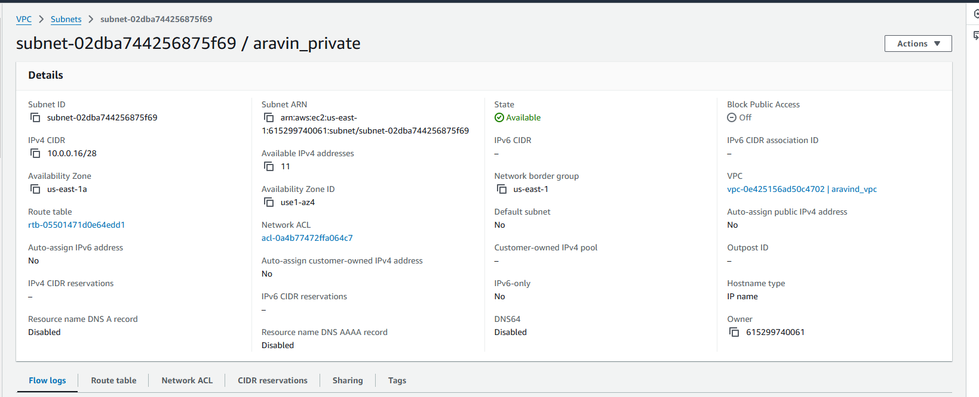*

*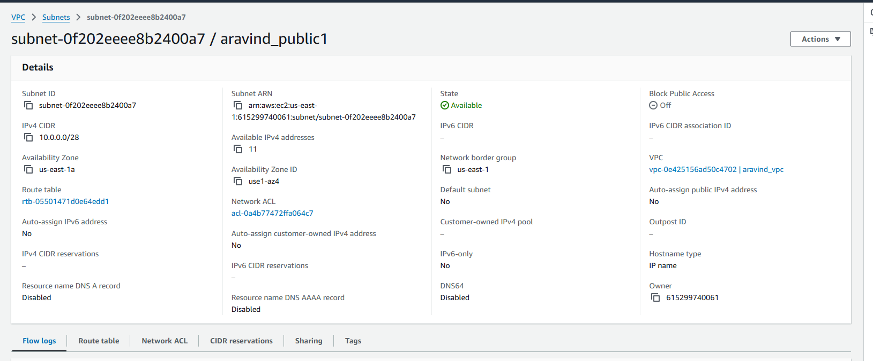*

*Provide the IGW to the vpc.*

*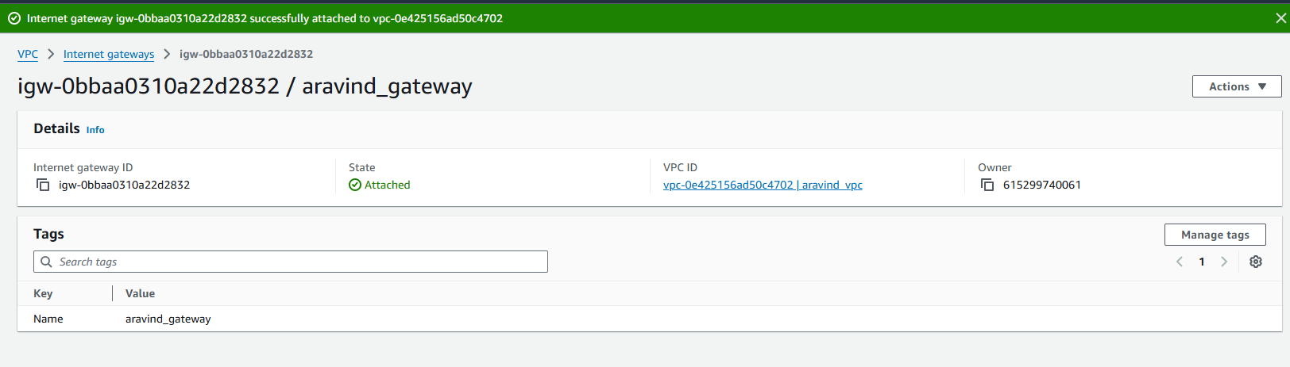*

*Create One public RT and one private RT.*

*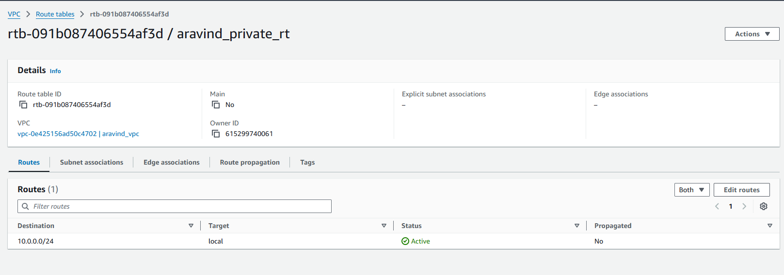*

*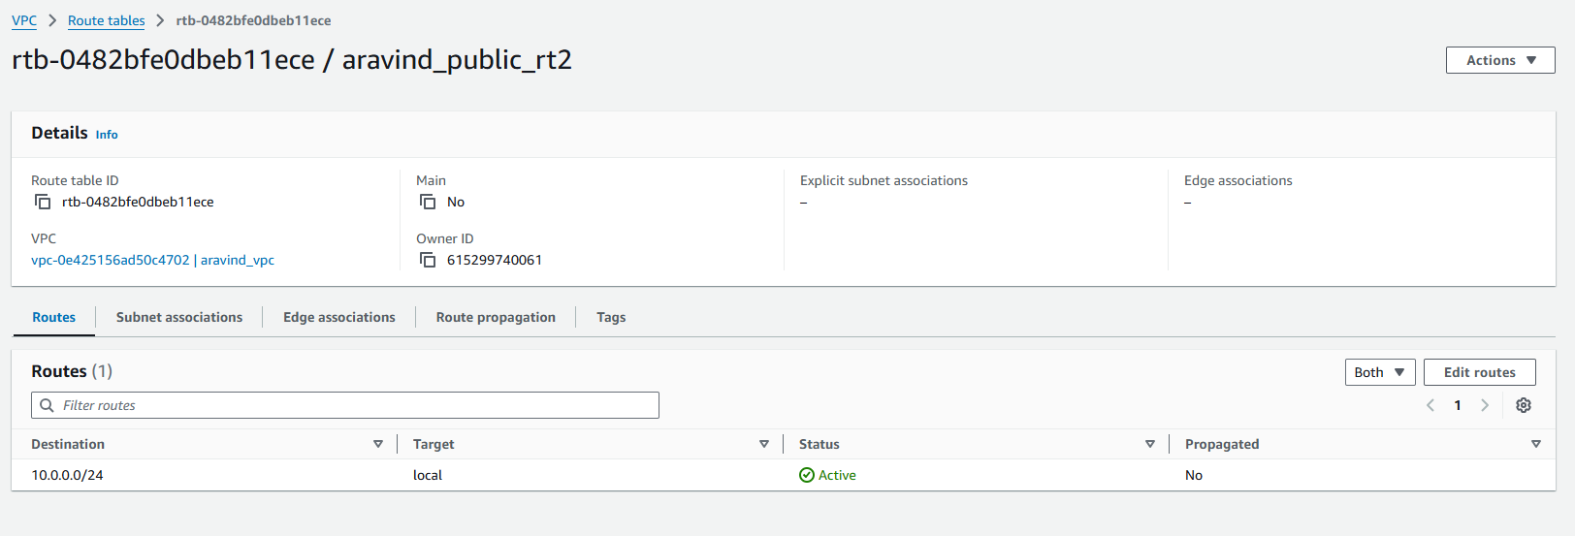*

*Deploy NAT gateway on public subnet and attach the NAT gatewat to private subnet.*

*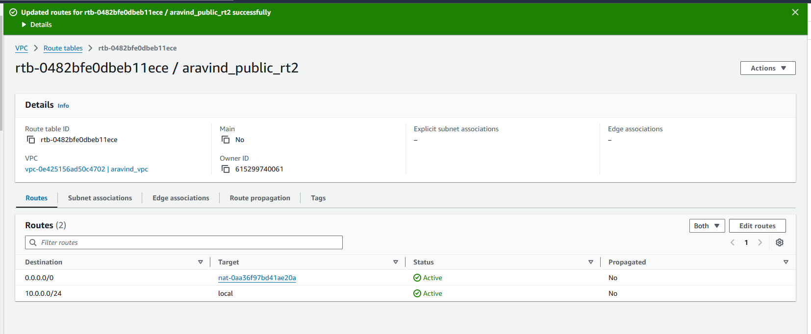*

*Create Two instances,one in public subnet and one in private subnet.*

*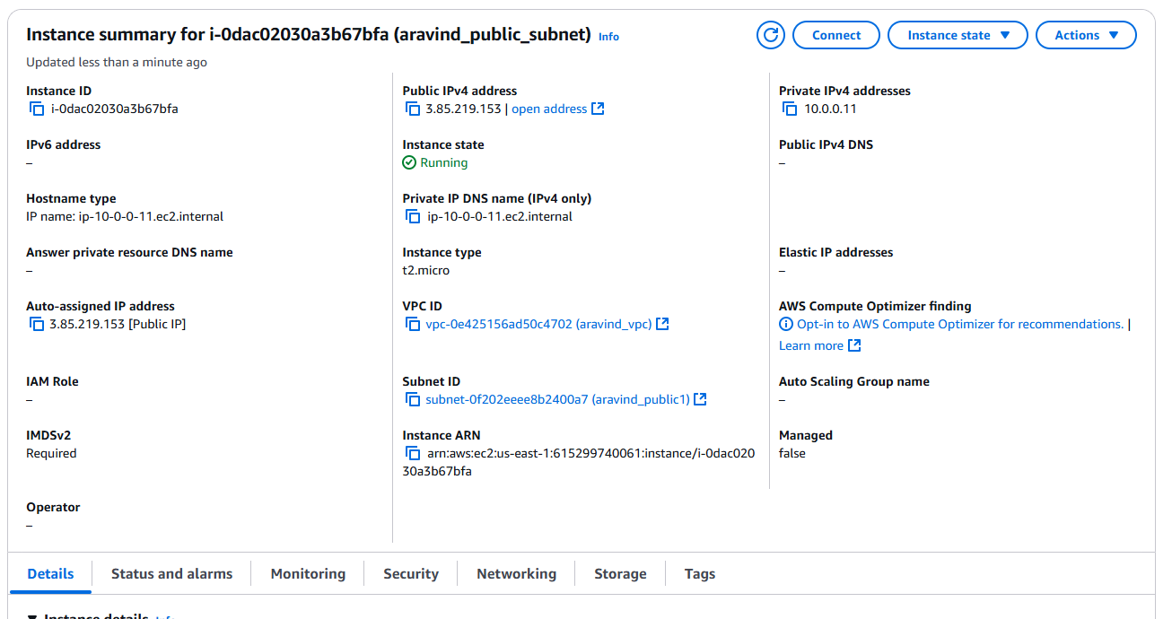*

*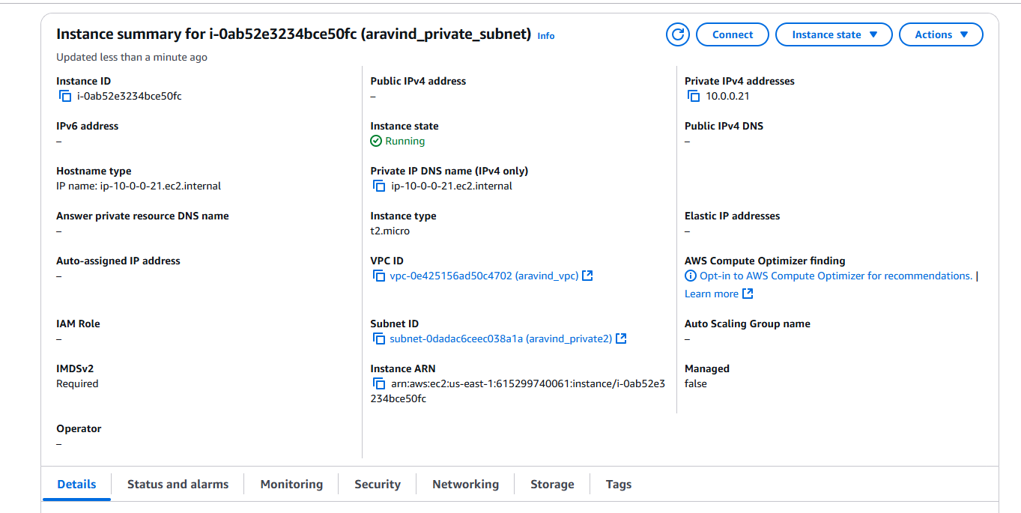*

*Deploy Apache server on both the ec2 instances with sample index.html file.*

*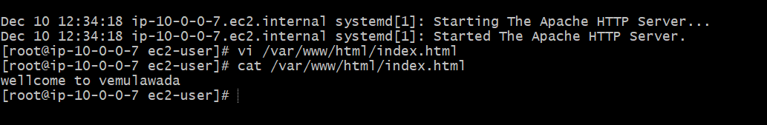*

*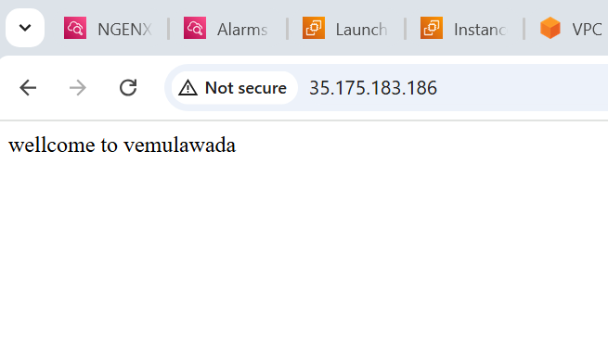*

*Create one application load balancer and attach the load balancer to both the ec2 instances  
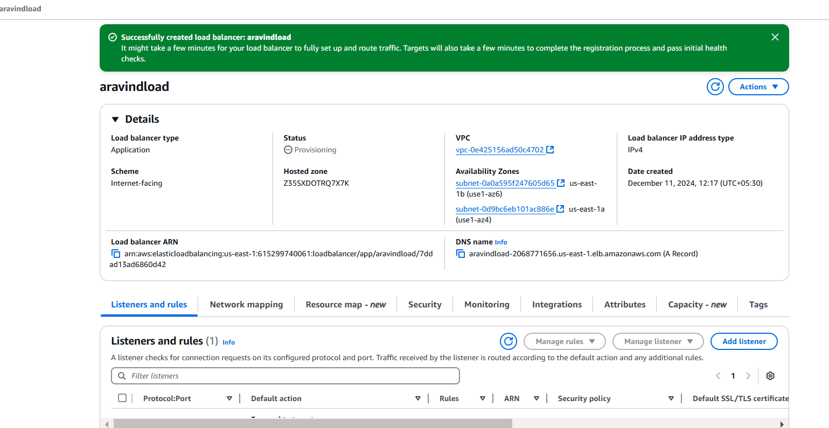*

*Store Application load balancer logs to s3.*

*